LAB 1 - Exploring Dictionary Methods in Python

Introduction

This lab manual is designed to help students gain hands-on experience in programming using dictionaries in Python. By working through exercises, students will understand how dictionary methods work, how data can be modified, and how to safely access and update dictionary elements.

Objectives:
- Create and manipulate dictionaries
- Use dictionary methods correctly
- Understand the difference between modifying and non-modifying methods
- Handle missing keys safely

Lab Setup Instructions
• Install Python
• IDE recommendation: VS Code.

Aim:
To explore and practice different dictionary methods in Python.
Theory Recap:
A dictionary in Python stores data in key–value pairs.
It is created using curly braces {}.
Example:
student = {"name": "Rahul", "age": 15, "grade": "10"}
Dictionary methods allow us to:
- Add elements
- Remove elements
- Access elements safely
- Copy dictionaries
- Update values
- Retrieve keys, values, and items
Some important dictionary methods:
Method | Description
clear() | Removes all elements
copy() | Returns a copy
get() | Returns value of a key
items() | Returns key-value pairs
keys() | Returns all keys
pop() | Removes element with specified key
popitem() | Removes last inserted pair
update() | Updates dictionary
values() | Returns all values
Exercises:
Q1. Create a dictionary named car with keys: brand, model, year.
Display all the keys using the appropriate method.
Q2. Use the get() method to display the value of the key model.
Q3. Add a new key color with value Red using the update() method.
Q4. Remove the key year using pop().
Q5. Use popitem() and observe which element is removed.
Q6. Create a copy of the dictionary using copy().
Modify the original dictionary and check if the copied dictionary changes.
Q7. Scenario:
You are a teacher preparing a report of your students’ marks. You want to find out which students scored more than 60.

Task:
- Ask the user (teacher) to input the names of 5 students.
- Ask the user to input their marks one by one.
- Store the student names as keys and marks as values in a dictionary.
- Using one for loop and one if condition, print the names of students who scored more than 60.

Input Example:
Enter name of student 1: Ali
Enter marks of Ali: 45
Enter name of student 2: Sara
Enter marks of Sara: 78
Enter name of student 3: Rahul
Enter marks of Rahul: 62
Enter name of student 4: Nina
Enter marks of Nina: 55
Enter name of student 5: Omar
Enter marks of Omar: 82
Expected Output:
Students scoring more than 60:
Sara
Rahul
Omar

Program / Experiment Code
Q1:
car = {"brand":"toyta","model":"camry","year":2019}
for i, v in car.items():
print(f"{i}: {v}")
Q2:
car = {"brand":"toyta","model":"camry","year":2019}
print(car.get('model'))
Q3:
car = {"brand":"toyta","model":"camry","year":2019}
car.update({"color":"red"})
print(car)
Q4:
car = {"brand":"toyta","model":"camry","year":2019}
car.pop('year')
print(car)
Q5:
car = {"brand":"toyta","model":"camry","year":2019}
car.popitem()
print(car) # key year is removed.
Q6:
car = {"brand":"toyta","model":"camry","year":2019}
copy = car.copy()
car.pop("brand")
print(copy)
Q7:
studentGrades = {}
for i in range(1, 6):
name = input(f"Enter #{i} student name: ")
grade = int(input(f"Enter marks of {name}: "))
studentGrades.update({name:grade})
print("Students who scored more than 60:")
for k, v in studentGrades.items():
if v > 60:
print(k)

Output
Q1:
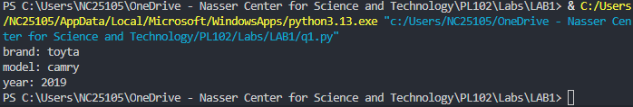
Q2:
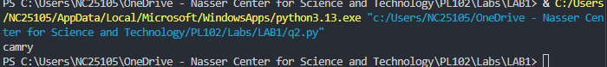
Q3:
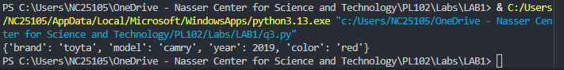
Q4:
Q5:
Q6:
Q7:
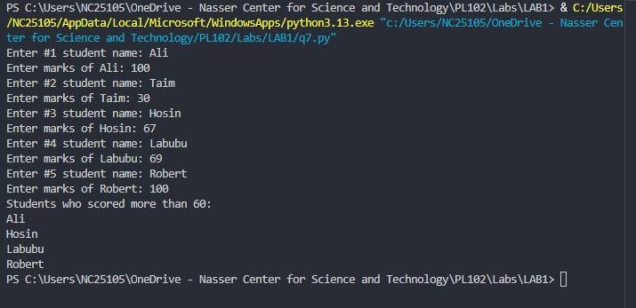
Result
The program executed successfully and demonstrated various dictionary methods such as get(), update(), pop(), copy(), and clear(). The objectives of understanding dictionary creation and manipulation were successfully achieved.

